Title of Your IDW ’23 Paper in 16 pt. Font with Capital Letters at the Beginning of Every Word except Prepositions and Articles
First Author’s Name¹, Second Author’s Name^{1,2}, in 13 pt. fonts
with the presenting author underlined
Corresponding author’s e-mail address
¹Affiliation and postal address of the author(s), in 9 pt. fonts
²Another affiliation and postal address of the author(s)
Keywords: List three to five keywords of your paper in 9 pt. fonts here within one line.

ABSTRACT
An abstract of 35-50 words in a 9 pt. The manuscript format of technical summary and the camera-ready manuscript are the same. The authors can use their Technical Summary as a Camera-Ready Manuscript if it meets the format, but all the authors must submit the Camera-Ready Manuscript.
- Introduction
The followings are the details about the file format, the composition, and the text contents in the manuscript.
  - File Format for Preparation
The manuscript must be prepared on A4-sized paper using this template.
  - File Format for Submission: PDF
The file format for submission is a PDF file. Please make PDF file in “high-quality” or “press-quality” with all of the used fonts embedded, and without any security options.
  - Margins
The top, left, right, and bottom margins must be 25 mm, 20 mm, 20 mm and 35 mm, respectively. Allow 10 mm for the column spacing.
  - Page Length
The maximum number of pages for the manuscript is four including text and figures/tables/photographs, and at least two pages must be filled up.
  - Headers and Footers
No header or footer is allowed for the authors to put in the manuscript. No page numbers may be included. The official headers for the paper identifiers and the footers for the page numbers will be added later by the committee.
  - Components and Column Structures
The manuscript should be composed of the following components in the order listed:
- Title of the paper centered at the top of the manuscript.
- Authors’ name(s) centered.
- Corresponding author’s e-mail address centered.
- Authors’ affiliations and postal addresses centered and distinguished by superscript numbers (1, 2, …).
- Three to five keywords for the papers centered in one line.
- Main text part in two-column format.
  - Sectioning the Main Text Part
The main text part (6) in two-column format should be sectioned as follows in the appearing order.
ABSTRACT as in the above sample.
1 Introduction
Author defined sections like standard ones in scientific papers such as “2 Experiment”, “3 Results”, and “4 Discussion”.
X Conclusions or Summary (X: final section number)
References (no section number)
Subsections (and sub-subsections) could be composed as necessary, and should also be hierarchically numbered as “x.y(.z)”.
  - Font Size and Typefaces
The font size must be 9 point or larger. Times New Roman, Helvetica, or Arial typefaces are recommended.
  - Headings and Subheadings
Major headings for top-level sections and sub-headings for subsections must be aligned to the left side of the column.
1.9.1 Third- order subheadings
Third-order subheadings for sub-subsections must be indented.
- Experiment
This section describes the details about the text content of the manuscript.
  - Title of Paper
The title of your paper should be placed at the top center of the manuscript. Title should be written in title case (the first letter of every word should be capital except prepositions, conjunctions and articles). Any use of commercial products names or registered trademarks in the title is strictly prohibited.
  - Authors’ Names
The authors’ names should be written in full and center placed just below the title. The name of the presenting author must be underlined.
  - Corresponding author’s e-mail address
The corresponding author’s e-mail address should be written just below the authors’ names as in this template.
  - Authors’ Affiliations
The affiliations and postal addresses of all the authors are placed just below the corresponding author’s e-mail address as in this template. Different affiliations should be distinguished as in the above Section 1.6 (4).
  - Keywords
Please list three to five keywords for your works presented in the paper centered just below the Authors’ Affiliations.
- Results
This section describes the detailed guidance for preparing figures and tables in the manuscript.
  - Colored Figures
Colored figures such as graphical plots and photographic images will be kept as prepared in the proceedings as shown in the example of Fig. 1.
  - Numbering and Captions
All figures and tables must be captioned with a figure or table number. Place the caption for a figure below the graphic; for a table, above. The font size in the captions must be 9 point or larger.
  - Hairlines
Avoid using “hairline” (the thinnest line thickness) as the weight of lines used in your figures and tables. The printed thickness of the “hairline” setting depends on the resolution of the printer used.
- Discussion
This section provides instructions for submission of your technical summary manuscript.
  - On-line Submission
Submit the electronic files of your manuscript file in PDF format via the web site.
https://www.idw.or.jp/authinfo.html
by submission deadline.
- Conclusions
For inquiries on the manuscript, please contact the IDW secretariat, idw-prog@idw.or.jp.
References
[1] Complete bibliographic information (names of “all” authors, “fully descriptive article titles”) in standard format such as AIP or IEEE style, for all cited references is required. See the examples below.
[2] S. Iijima, “Toward Industrial Application of Carbon Nanotube,” Proc. IDW ’03, pp. 3-4 (2003).
[3] K. Maeda and Y. Nakao, “Mechanical properties and fracture analysis of glass substrate for PDPs,” J. SID, Vol. 11, No. 3, pp. 481-484 (2003).
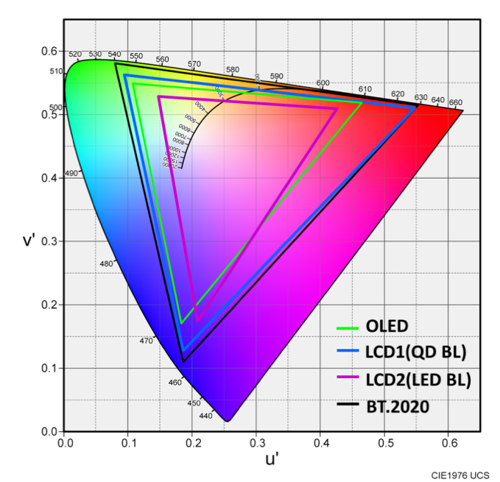
Fig. 1 Color figure

